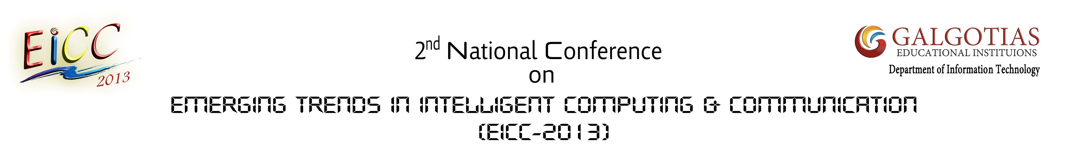
Non-Author Attendee Registration Form
(Download and Complete)

Full Name: ______________________________________________________________________________
Job Title (Position): _______________________________________________________________________
College/Organization: _____________________________________________________________________
Preferred Mailing Address: ________________________________________________________________
City: _____________________State: _______________________ Zip/Postal Code: _________________
Country: _____________________________ Mobile: __________________________________________
Email: _________________________________________________________________________________

CONFERENCE FEES Rs. 200/-

Please check appropriate box:  Cash  Demand Draft*
Rs._______________ DD No.:_______________________ Date: _______________________________
Issuing Bank Detail with Branch Address: _________________________________________________
Please mail completed registration form with payment to:

The Secretary (EICC-2013)
Department of IT
Galgotias College of Engineering and Technology
Greater Noida, 201306
U.P. India.

*Demand Draft (drawn in favor of: Galgotias College of Engineering & Technology” payable at Greater Noida.)

